**QUANTUMHUNTS TASKS**

**NAME : SNEKA P**

**REG NO : 1934045**

**DEPT : Msc AIML**

**TASK 1:**

**A table contains students from different classes taking part in a game. All their details are stored in a common table as given below.**

**1. These entries are present in an MySql table**

CREATE TABLE student_detail (

id INT PRIMARY KEY,

class_name VARCHAR(20),

student_name VARCHAR(30));

INSERT INTO student_detail (id, class_name, student_name) VALUES (1, 'Class A', 'Arun'),

(2, 'Class B', 'Tejas'),

(3, 'Class B', 'David'),

(4, 'Class A', 'Uma'),

('5, Class B', 'Divya'),

(6, 'Class A', 'Simon'),

(7, 'Class A', 'Rakesh'),

(8, 'Class B', 'Selvam'),

(9, 'Class B', 'Shruthi'),

(10, 'Class A', 'Deepak');

**QUERY:**

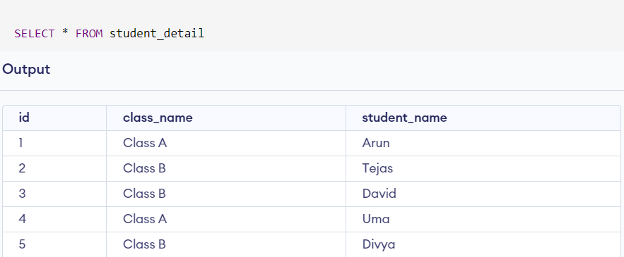 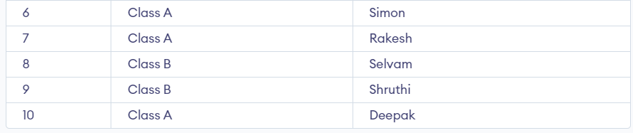

**2. Build a drag drop model UI using bootstrap.**

<!DOCTYPE html>

<html lang="en">

<head>

  <meta charset="UTF-8">

  <meta name="viewport" content="width=device-width, initial-scale=1.0">

  <title>Bootstrap Drag and Drop</title>

  <link rel="stylesheet" href="https://stackpath.bootstrapcdn.com/bootstrap/4.5.2/css/bootstrap.min.css">

  <style>

    .drag-container {

      display: grid;

      grid-template-columns: repeat(3, 1fr);

      gap: 20px;

    }

    .draggable-item {

      border: 1px solid #ddd;

      padding: 10px;

      cursor: move;

    }

  </style>

</head>

<body>

<div class="container mt-5">

  <h2 class="mb-4">Students dashboard</h2>

  <div class="drag-container">

    <div class="draggable-item" draggable="true" ondragstart="drag(event)">Arun</div>

    <div class="draggable-item" draggable="true" ondragstart="drag(event)">Tejas</div>

    <div class="draggable-item" draggable="true" ondragstart="drag(event)">David</div>

    <div class="draggable-item" draggable="true" ondragstart="drag(event)">Uma</div>

    <div class="draggable-item" draggable="true" ondragstart="drag(event)">Divya</div>

    <div class="draggable-item" draggable="true" ondragstart="drag(event)">Simon</div>

    <div class="draggable-item" draggable="true" ondragstart="drag(event)">Rakesh</div>

    <div class="draggable-item" draggable="true" ondragstart="drag(event)">Selvam</div>

    <div class="draggable-item" draggable="true" ondragstart="drag(event)">Shruthi</div>

    <div class="draggable-item" draggable="true" ondragstart="drag(event)">Deepak</div>

  </div>

</div>

<script>

  function drag(ev) {

    ev.dataTransfer.setData("text", ev.target.innerText);

  }

  function allowDrop(ev) {

    ev.preventDefault();

  }

  function drop(ev) {

    ev.preventDefault();

    var data = ev.dataTransfer.getData("text");

    var newItem = document.createElement("div");

    newItem.className = "draggable-item";

    newItem.textContent = data;

    newItem.draggable = true;

    newItem.ondragstart = drag;

    ev.target.appendChild(newItem);

  }

</script>

</body>

</html>

**OUTPUT:**

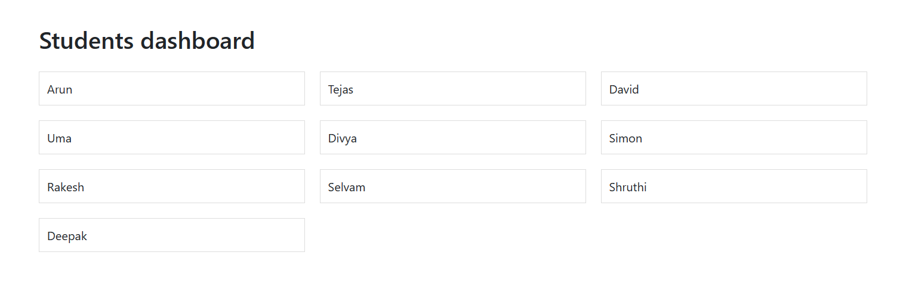

**TASK 2 :**

**Feature - Login to website using gmail/facebook or Allow users to sign-up to a website using gmail or facebook credential by one click login.**

**1. Create a main page with two buttons.**

<!DOCTYPE html>

<head>

    <title>Sample Web Page</title>

    <link rel="stylesheet" href="https://maxcdn.bootstrapcdn.com/bootstrap/3.4.1/css/bootstrap.min.css">

    <script src="https://apis.google.com/js/platform.js" async defer></script>

    <meta name="google-signin-client_id" content="{your_client_key}.apps.googleusercontent.com">

</head>

<body>

    <button type="button" class="btn btn-danger">Login with Gmail</button>

    <div class="g-signin2" data-onsuccess="onSignIn"></div>

    <button type="button" class="btn btn-primary">Login with Facebook</button>

    <div class="fb-login-button" data-width="" data-size="large" data-button-type="continue_with" data-layout="default"

        data-auto-logout-link="false" data-use-continue-as="false" data-onlogin="checkLoginState"></div>

    <!-- Include the Facebook SDK -->

    <script async defer crossorigin="anonymous" src="https://connect.facebook.net/en_US/sdk.js"></script>

    <script>

        function onSignIn(googleUser) {

            var profile = googleUser.getBasicProfile();

            console.log('ID: ' + profile.getId());

            console.log('Name: ' + profile.getName());

            console.log('Image URL: ' + profile.getImageUrl());

            console.log('Email: ' + profile.getEmail());

            // You can perform additional actions here, such as sending the user's data to your server.

        }

    </script>

</body>

</html>

**OUTPUT:**

